# B.M.S COLLEGE OF ENGINEERING BENGALURU

Autonomous Institute, Affiliated to VTU



# LAB REPORT 23CS3PCOOJ

Submitted in partial fulfilment of the requirements for Lab Bachelor of Engineering

in

Computer Science and Engineering

Submitted by:

# PRAJWAL C (1BM22CS198)

Department of Computer Science and Engineering,

B.M.S College of Engineering,

Bull Temple Road, Basavanagudi, Bangalore, 560 019 2023-2024.

# INDEX

|  |  |  |
| --- | --- | --- |
| **Sl.No.** | **Title** | **Date** |
| 1 | Complete scanned Observation Book | 12/12/2023 -  20/02/2024 |
| 2 | Lab 1 | 12/12/2023 |
| 3 | Lab 2 | 19/12/2023 |
| 4 | Lab 3 | 26/12/2023 |
| 5 | Lab 4 | 02/01/2024 |
| 6 | Lab 5 | 09/01/2024 |
| 7 | Lab 6 | 16/01/2024 |
| 8 | Lab 7 | 23/01/2024 |
| 9 | Lab 8 | 30/01/2024 |
| 10 | Lab 9 | 06/02/2024 |
| 11 | Lab 10 | 20/02/2024 |

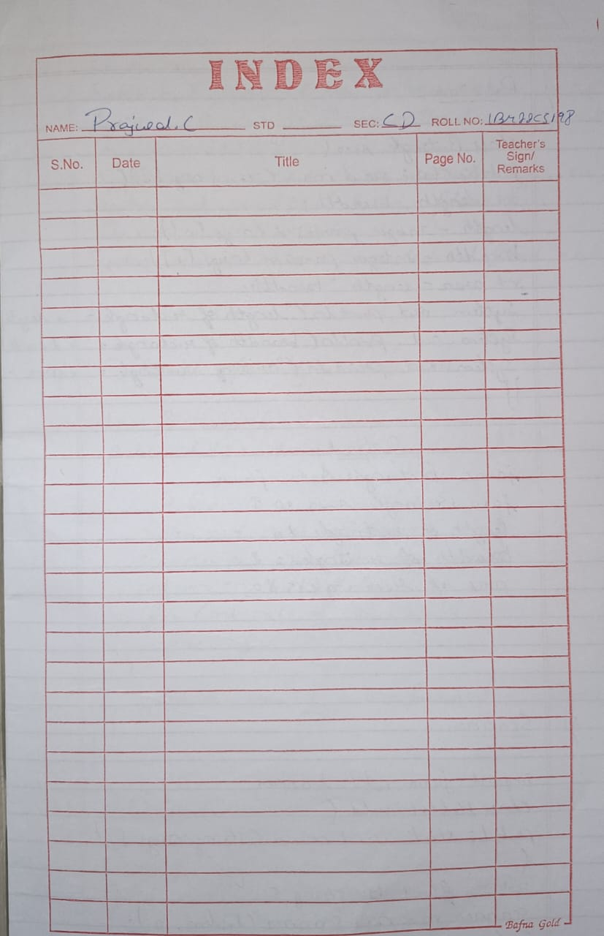

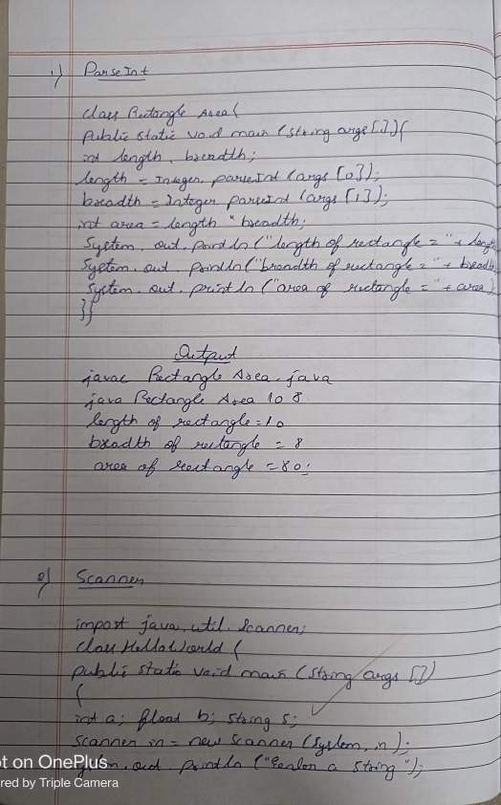

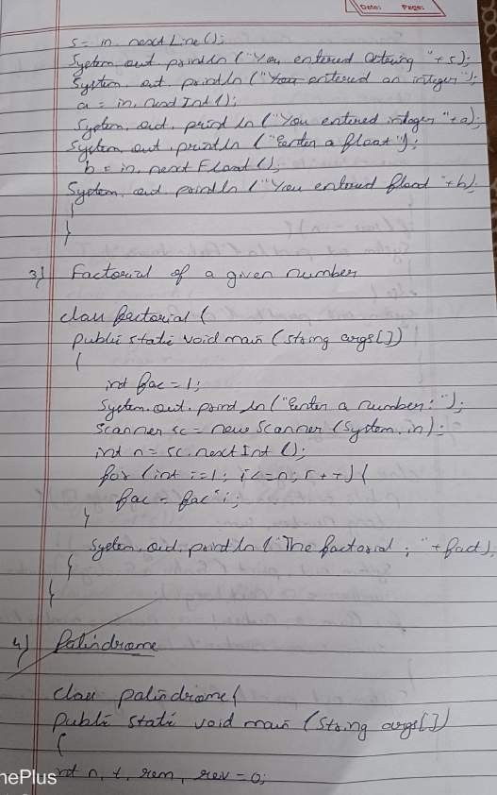

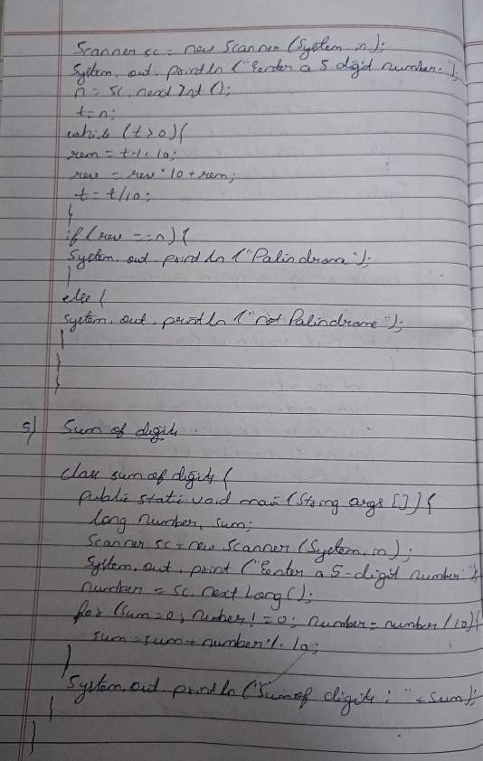

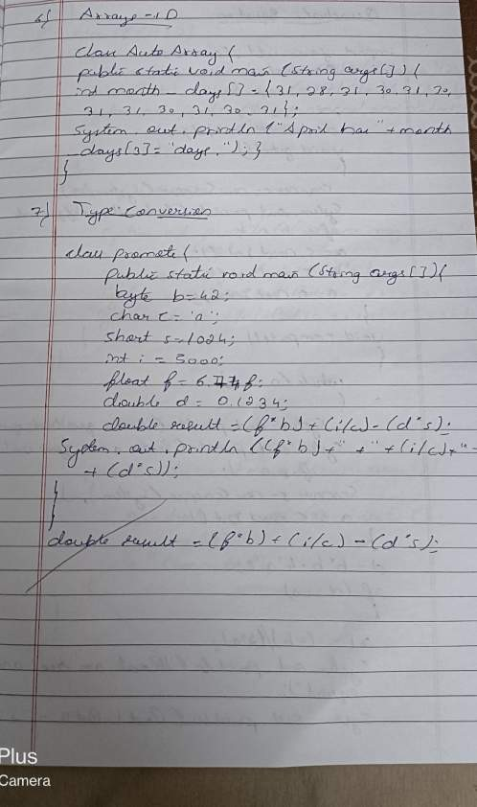

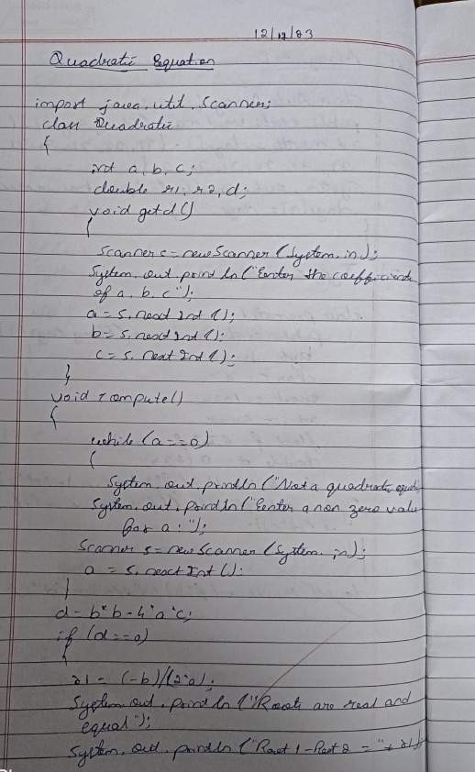

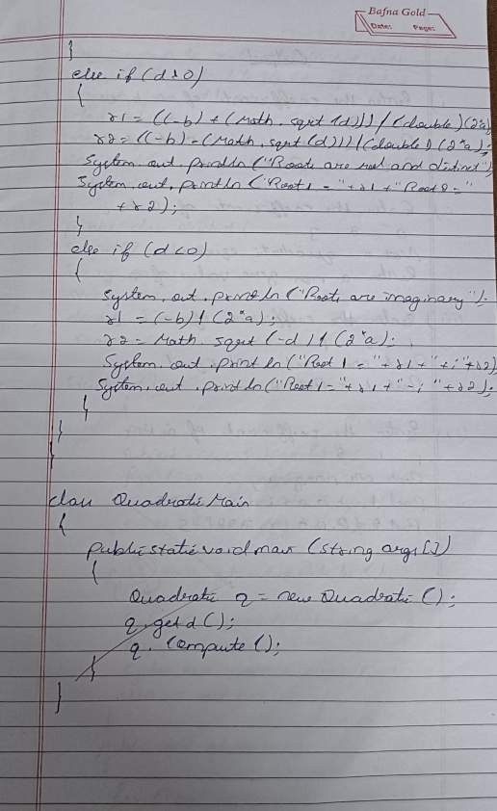

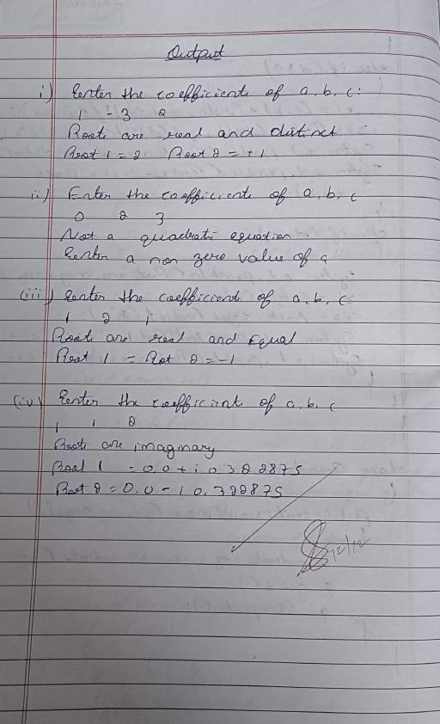

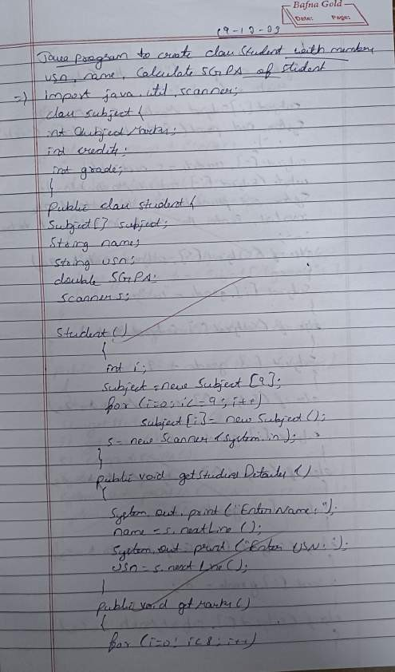

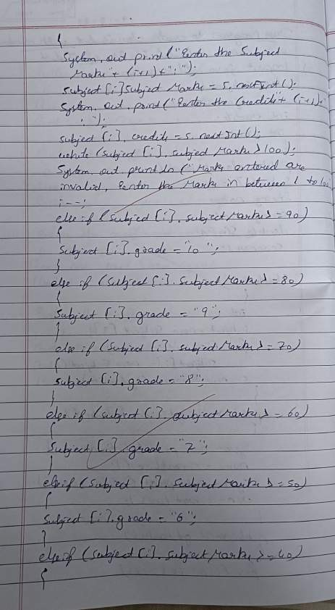

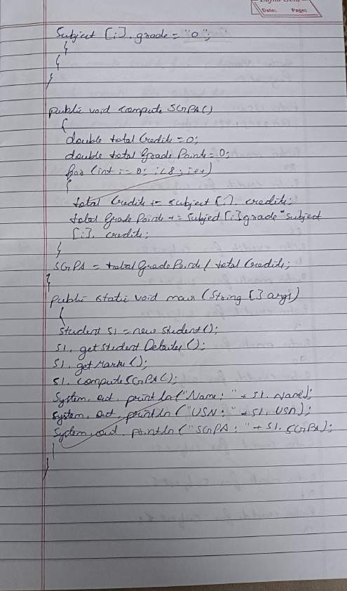

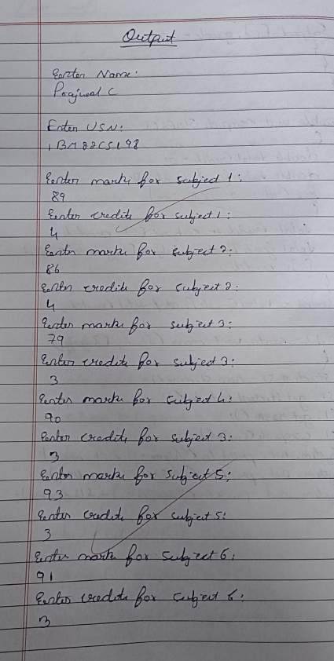

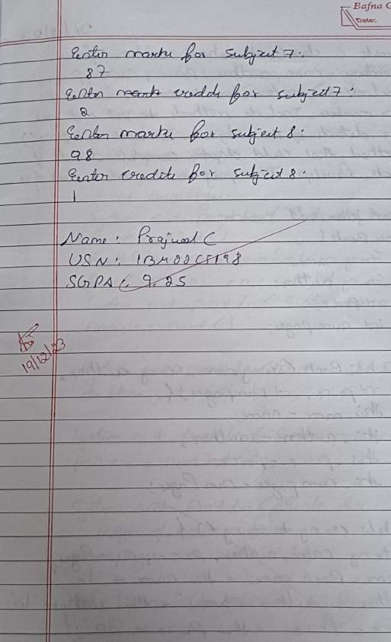

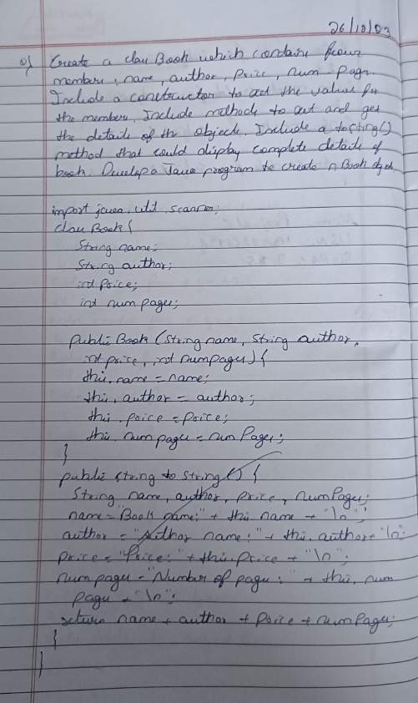

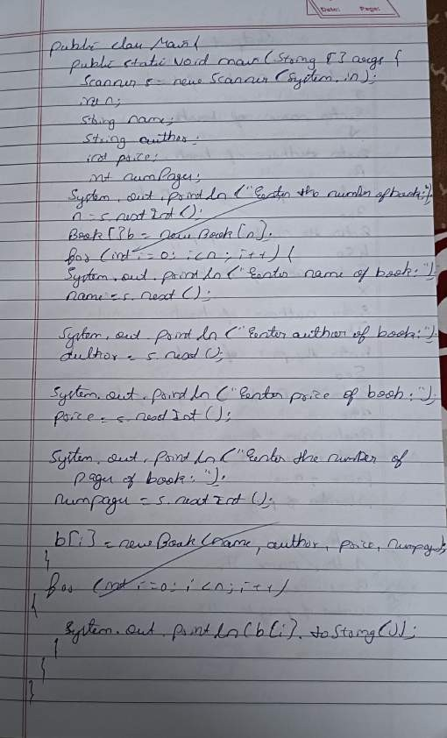

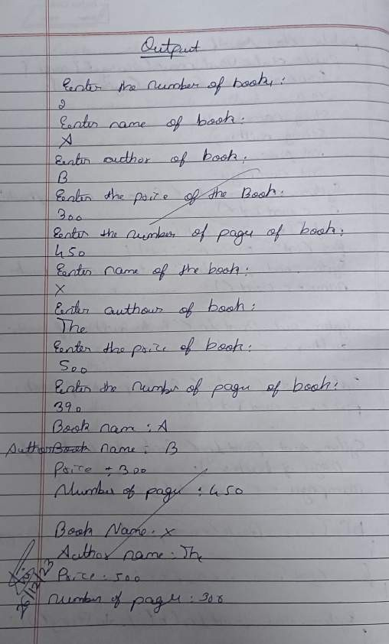

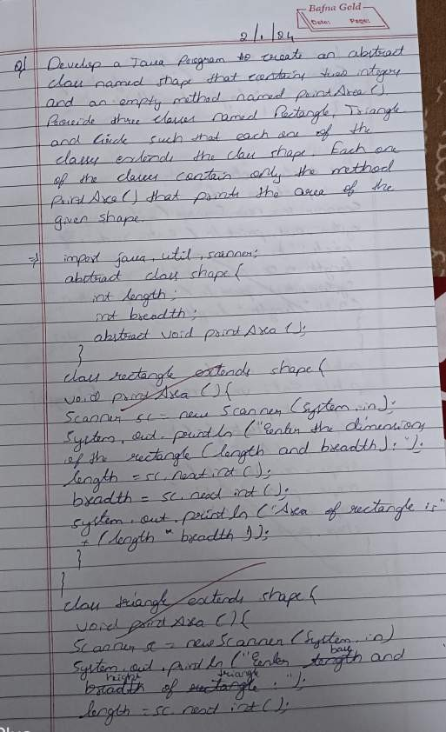

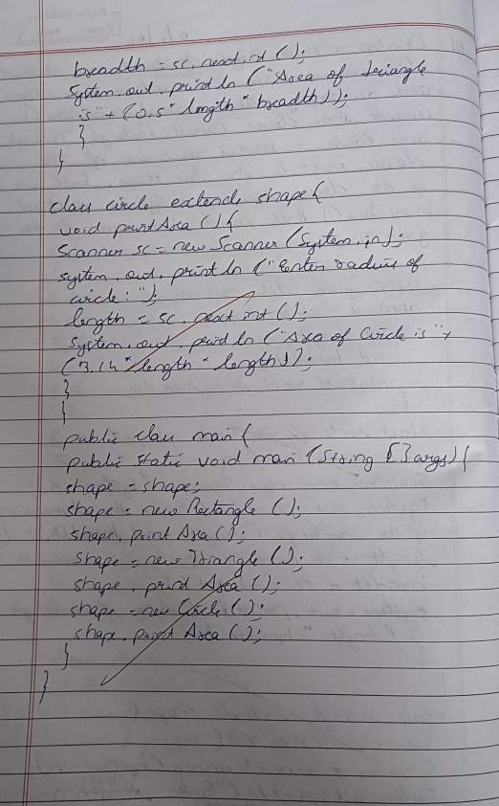

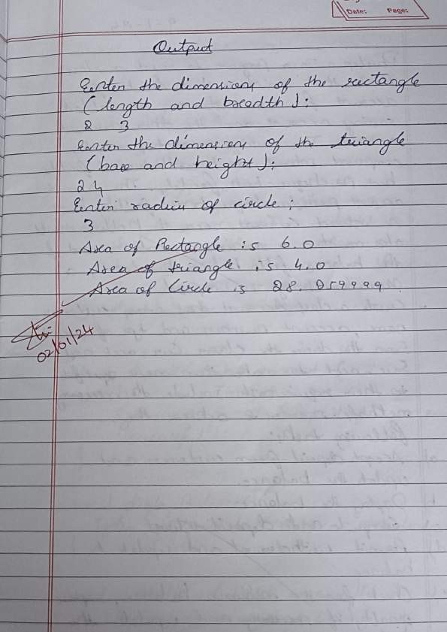

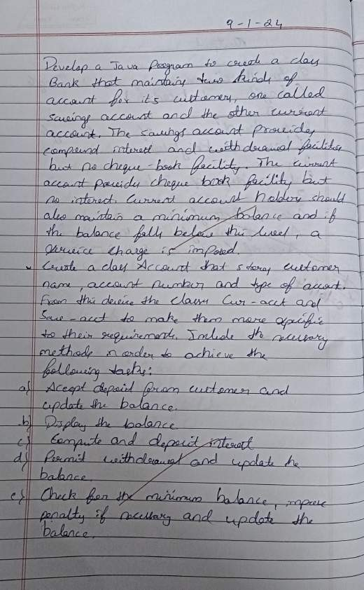

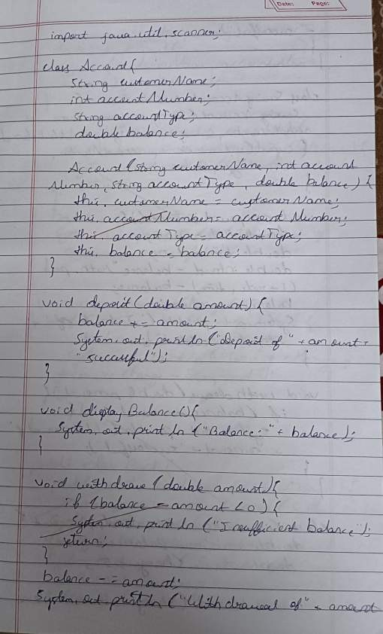

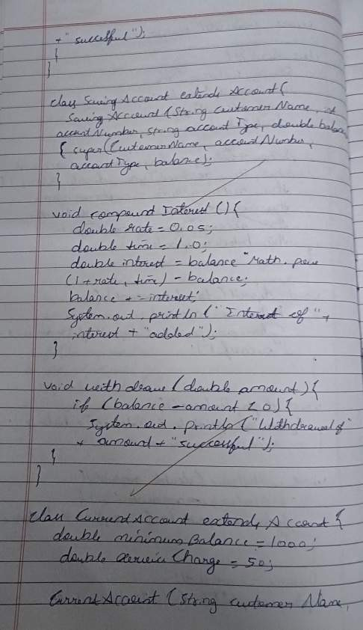

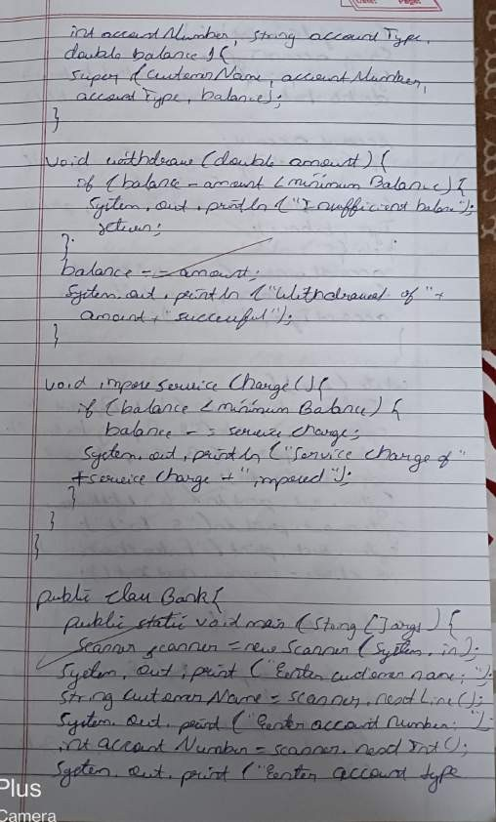

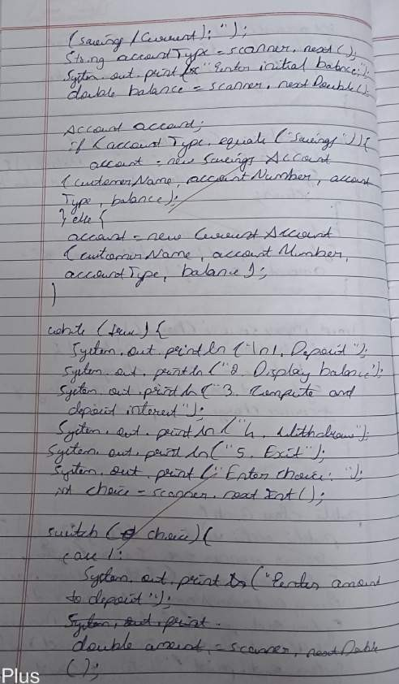

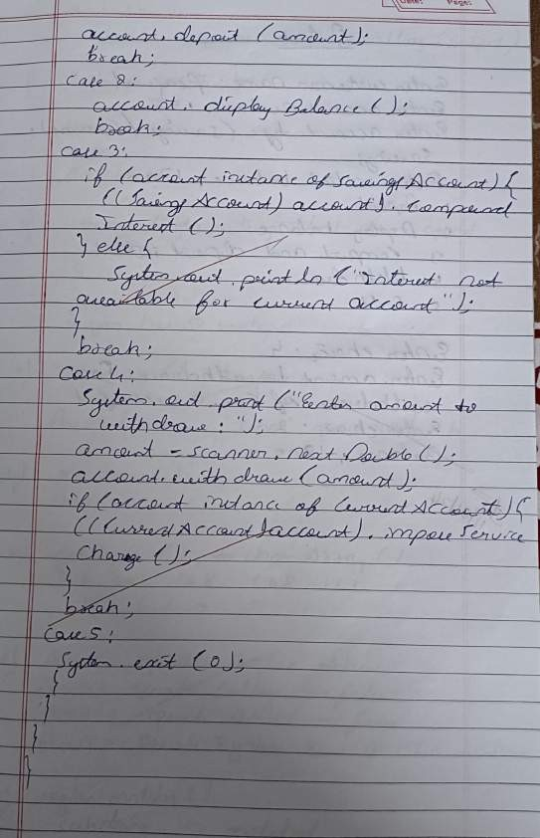

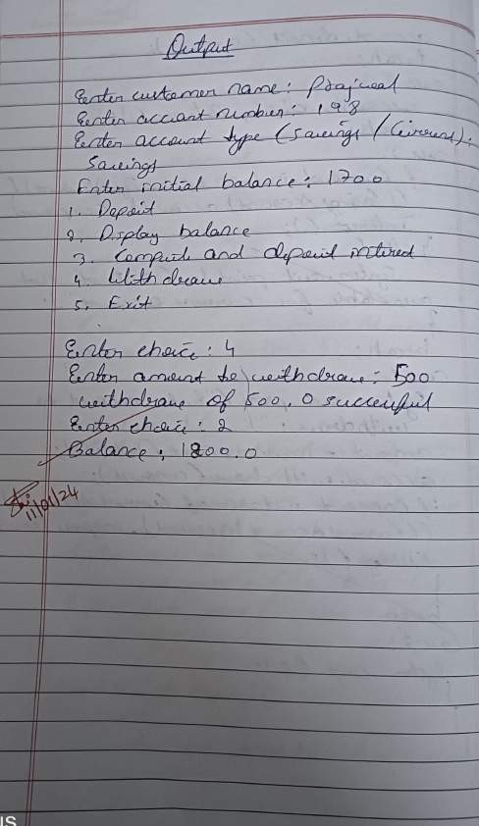

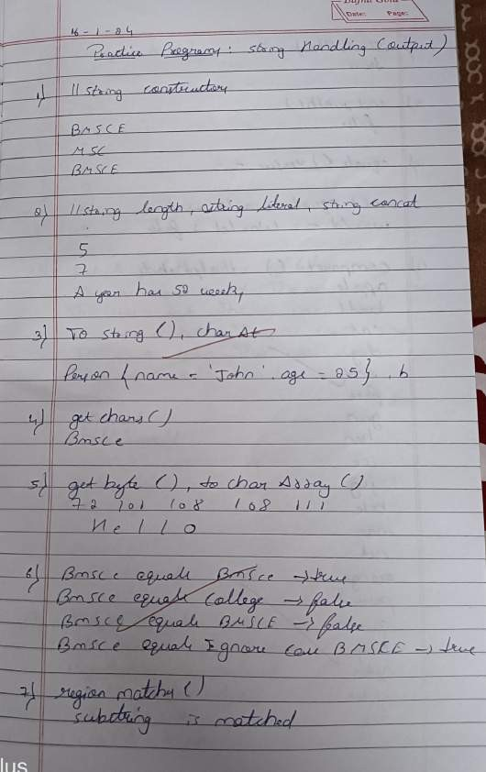

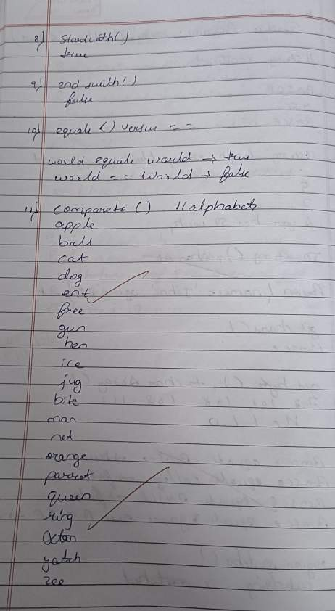

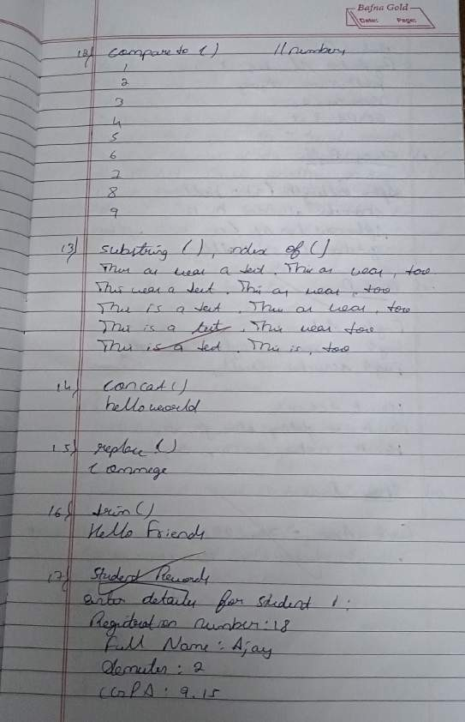

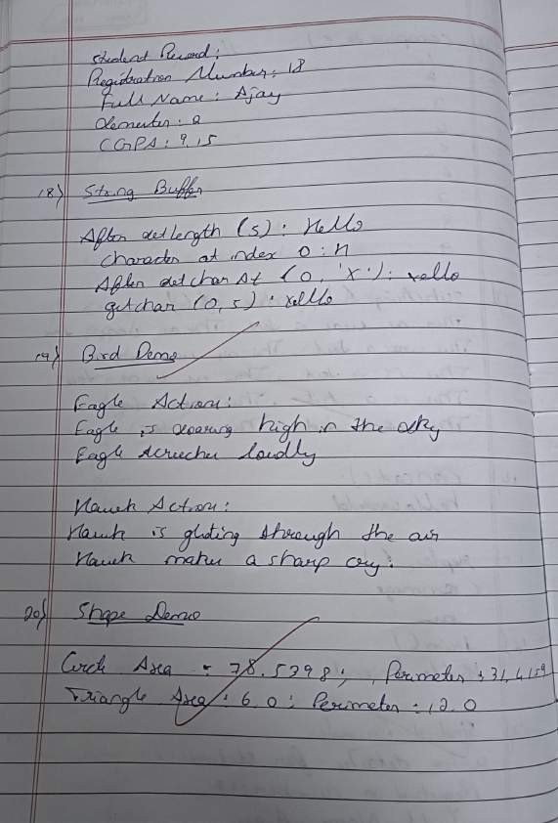

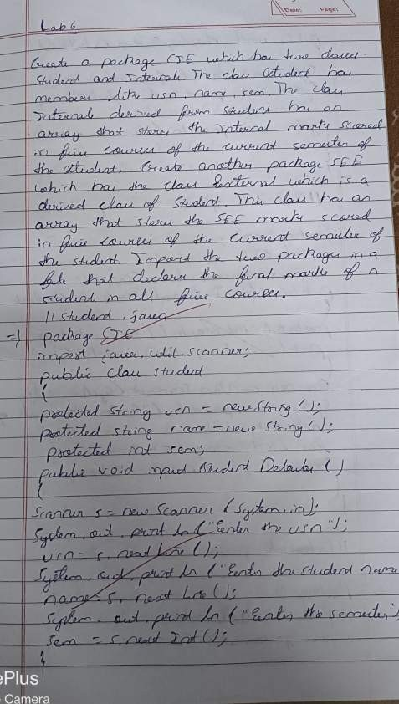

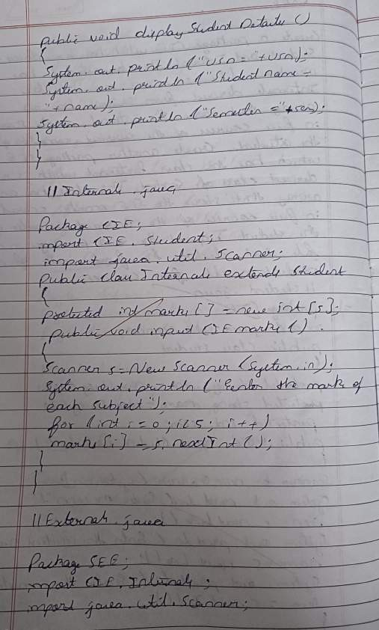

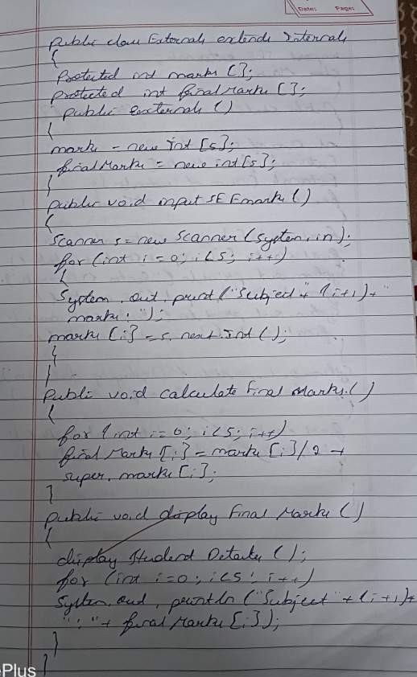

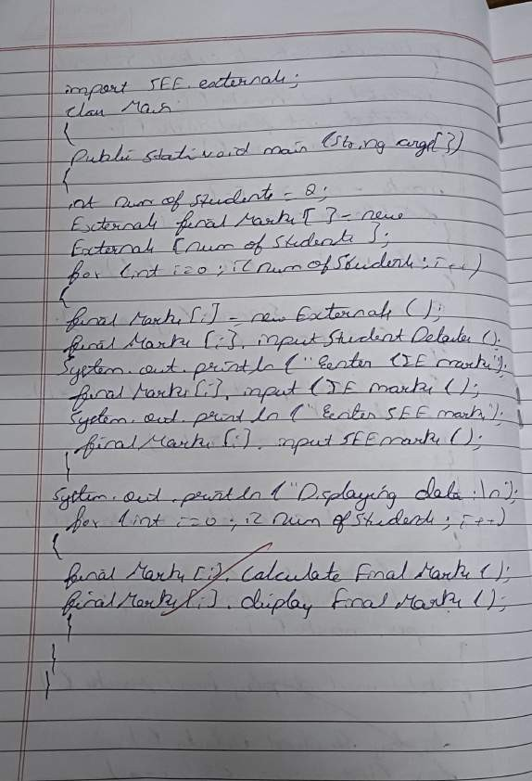

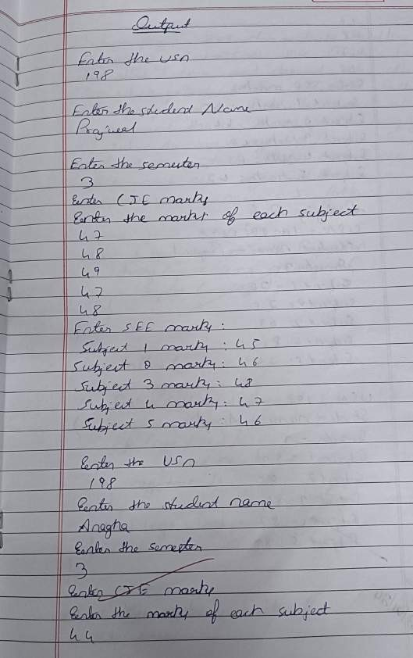

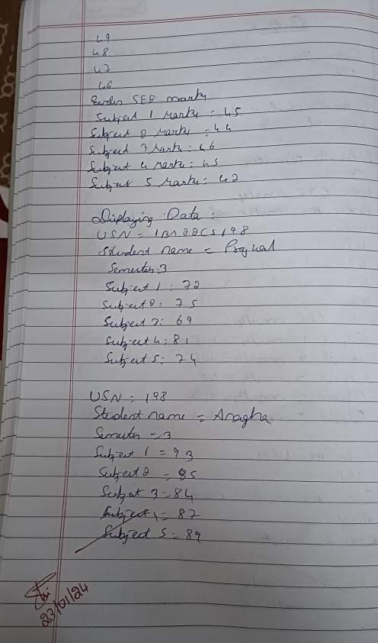

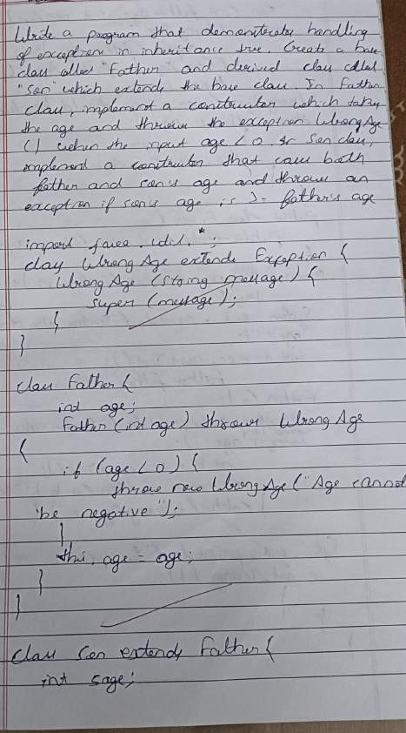

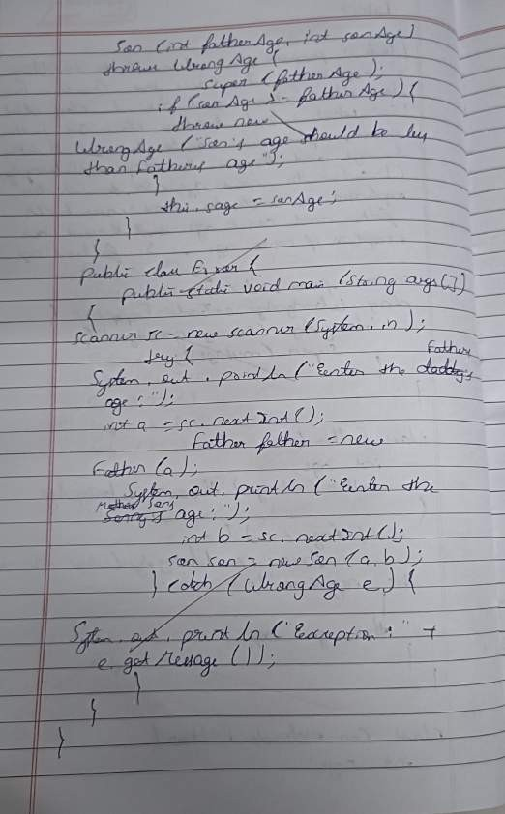

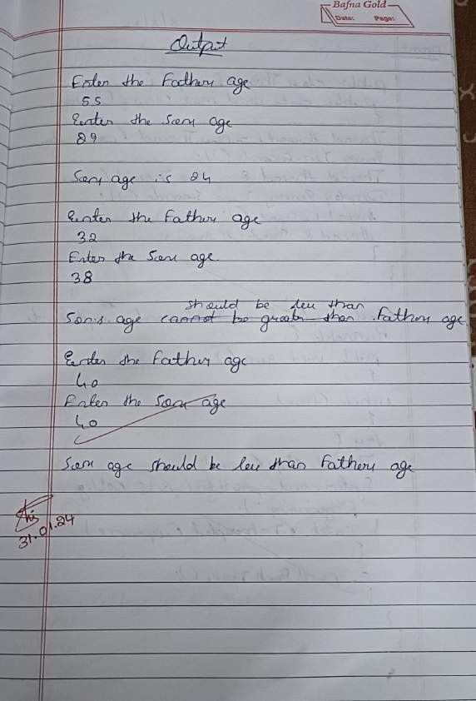

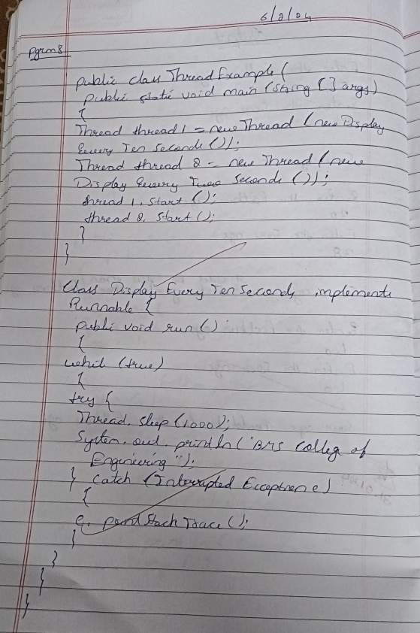

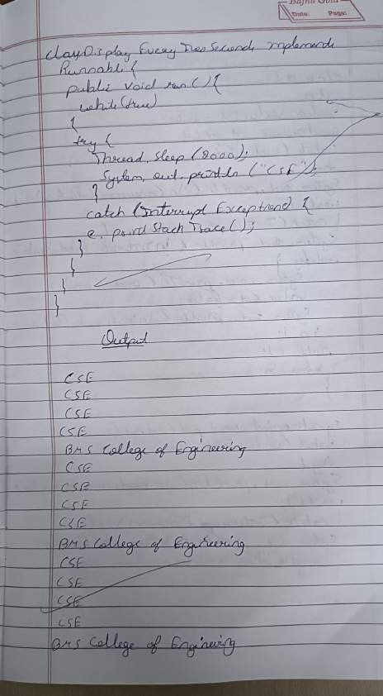

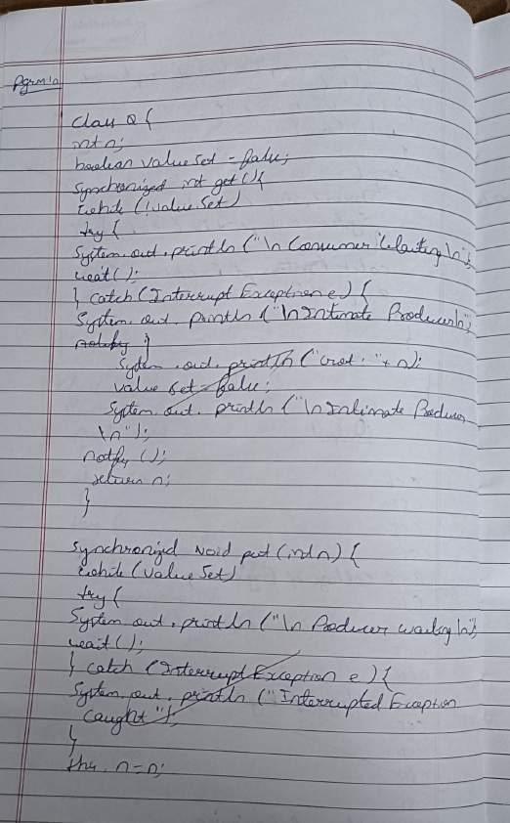

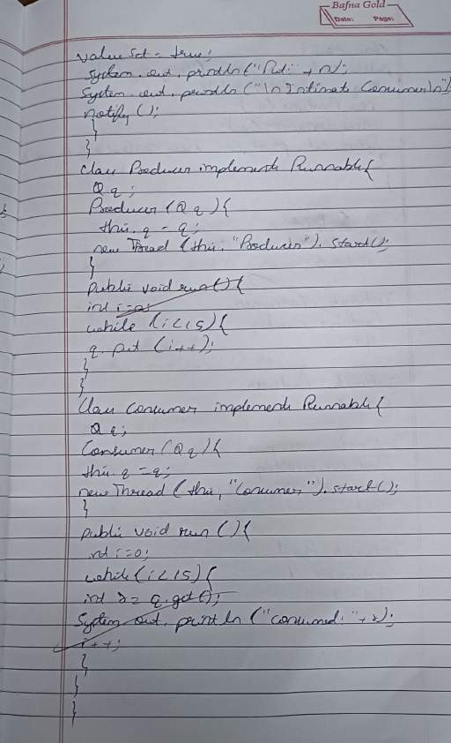

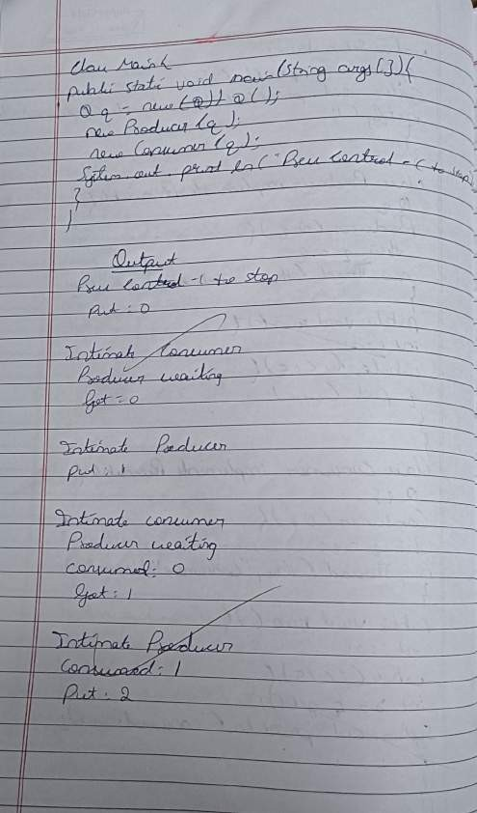

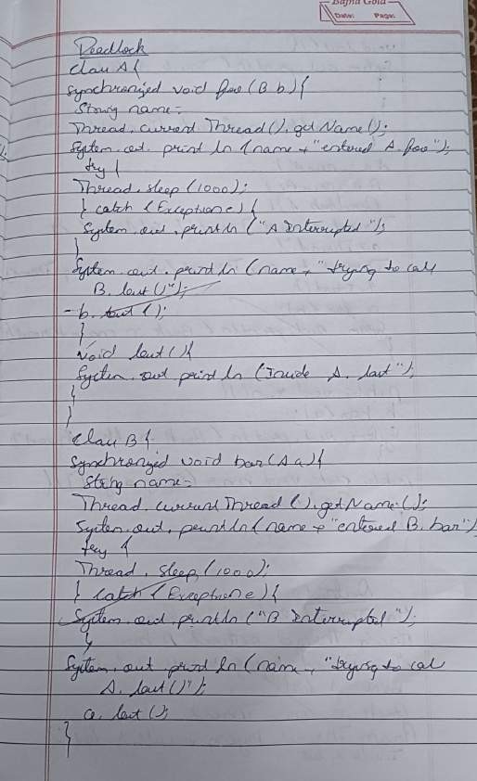

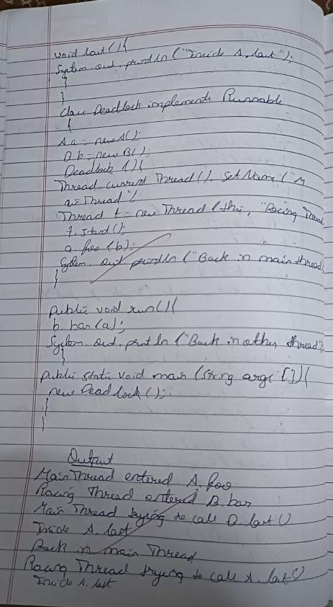

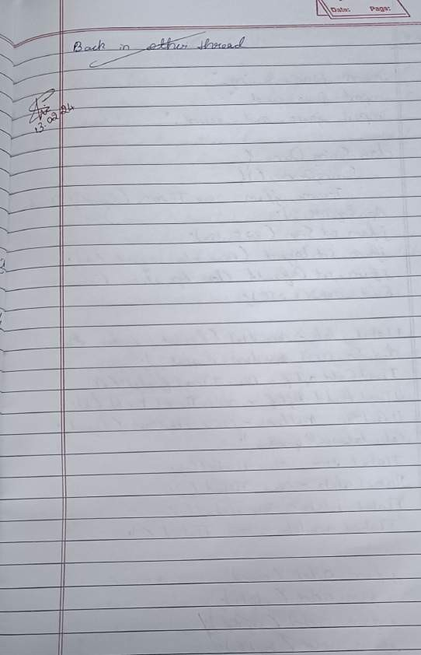

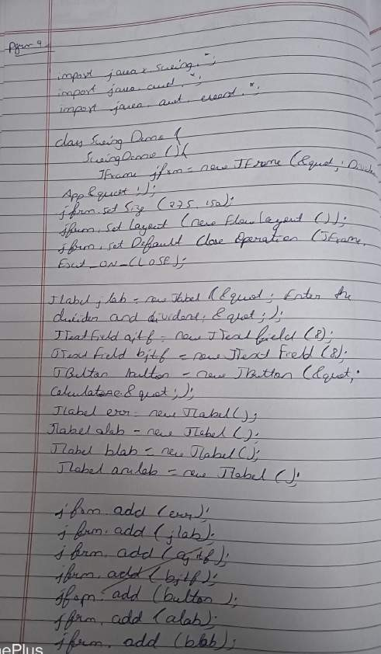

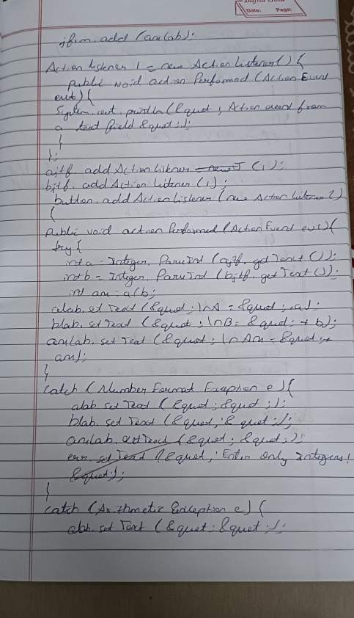

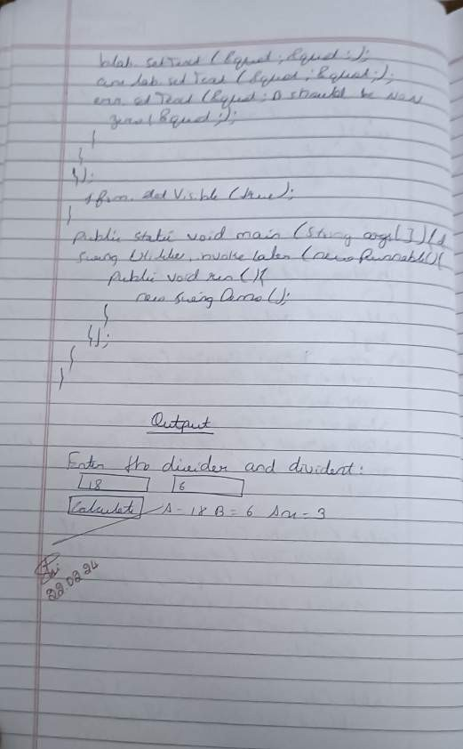

Develop a Java program that prints all real solutions to the quadratic equation ax 2 +bx+c = 0. Read in a, b, c and use the quadratic formula. If the discriminate b^2 – 4ac is negative, display a message stating that there are no real solutions.

import java.util.Scanner; class Quadratic

{

int a, b, c; double r1, r2, d; void getd()

{

Scanner s = new Scanner(System.in); System.out.println("Enter the coefficients of a,b,c");

a = s.nextInt();

b = s.nextInt();

c = s.nextInt();

}

void compute()

{

while(a==0)

{

System.out.println("Not a quadratic equation"); System.out.println("Enter a non zero value for a:"); Scanner s = new Scanner(System.in);

a = s.nextInt();

}

d = b*b-4*a*c; if(d==0)

{

r1 = (-b)/(2*a);

System.out.println("Roots are real and equal"); System.out.println("Roo1 = Root2 = " + r1);

}

else if(d&gt;0)

{

r1 = ((-b)+(Math.sqrt(d)))/(double)(2*a);

r2 = ((-b)-(Math.sqrt(d)))/(double)(2*a); System.out.println("Roots are real and distinct"); System.out.println("Roo1 = " + r1 + " Root2 = " + r2);

}

else if(d&lt;0)

{

System.out.println("Roots are imaginary"); r1 = (-b)/(2*a);

r2 = Math.sqrt(-d)/(2*a); System.out.println("Root1 = " + r1 + " + i"+r2); System.out.println("Root1 = " + r1 + " - i"+r2);

}

}

}

class QuadraticMain

{

public static void main(String args[])

{

Quadratic q = new Quadratic(); q.getd();

q.compute();

}

}

# LAB PROGRAM 2

## Develop a Java program to create a class Student with members usn, name, an array credits and an array marks. Include methods to accept and display details and a method to calculate SGPA of a student.

import java.util.Scanner; class subject{

int subjectMarks, credits, grade;} class Student {

String name; String usn; double SGPA; Scanner s; subject subjects[];

Student()

{

int i;

subjects = new subject[9]; for(i=0;i<8;i++)

subjects[i] = new subject(); s = new Scanner(System.in);

}

public void getStudentDetails(){ System.out.println("Enter student name:"); name=s.nextLine(); System.out.println("Enter Student USN:"); usn=s.nextLine();}

public void getMarks(){ int i;

for(i=0;i<8;i++){

System.out.println("Enter marks of subject"+(i+1)+":"); subjects[i].subjectMarks= s.nextInt(); if(subjects[i].subjectMarks>=40&&subjects[i].subjectMarks<=100){ subjects[i].grade=calculateGrade(subjects[i].subjectMarks);}

else{

System.out.println("Invalid Marks. Marks should be between 40 and 100");} System.out.println("enter credits:");

subjects[i].credits=s.nextInt();

}

}

public int calculateGrade(int marks){ if (marks>=90)

return 10;

else if(marks>=70&&marks<=80) return 9;

else if(marks>=60&&marks<=70) return 8;

else if(marks>=50&&marks<=60) return 7;

else return 6;

}

public void computeSGPA() { int totalscore = 0;

int totalcred = 0;

for (int i = 0; i < 8; i++) {

totalscore += subjects[i].grade * subjects[i].credits; totalcred += subjects[i].credits;

}

SGPA = (double) totalscore / (double) totalcred;

}

}

class Stud{

public static void main(String args[]){ Student s1=new Student(); s1.getStudentDetails();

s1.getMarks(); s1.computeSGPA();

System.out.println("Student name:"+s1.name); System.out.println("Student usn:"+s1.usn);

System.out.println("Student sgpa:"+s1.SGPA);}

}

# LAB PROGRAM 3

## Create a class Book which contains four members: name, author, price, num_pages. Include a constructor to set the values for the members. Include methods to set and get the details of the objects. Include a toString( ) method that could display the complete details of the book. Develop a Java program to create n book objects.

import java.util.Scanner; class Book {

private String name; private String author; private double price;

private int numPages;

public Book(String name, String author, double price, int numPages) { this.name = name;

this.author = author; this.price = price; this.numPages = numPages;

}

public void setName(String name) { this.name = name;

}

public String getName() { return name;

}

public void setAuthor(String author) { this.author = author;

}

public String getAuthor() { return author;

}

public void setPrice(double price) {

this.price = price;

}

public double getPrice() { return price;

}

public void setNumPages(int numPages) { this.numPages = numPages;

}

public int getNumPages() { return numPages;

}

public String toString() {

return "Book Details: \nName: " + name + "\nAuthor: " + author + "\nPrice: INR" + price + "\nNumber of Pages: " + numPages;

}

}

public class Main {

public static void main(String[] args) { Scanner scanner = new Scanner(System.in);

System.out.println("Enter the number of books: "); int n = scanner.nextInt();

Book[] books = new Book[n]; for (int i = 0; i < n; i++) {

System.out.println("\nEnter details for Book " + (i + 1) + ":"); scanner.nextLine();

System.out.println("Enter name: "); String name = scanner.nextLine(); System.out.println("Enter author: "); String author = scanner.nextLine(); System.out.println("Enter price: "); double price = scanner.nextDouble();

System.out.println("Enter number of pages: "); int numPages = scanner.nextInt();

books[i] = new Book(name, author, price, numPages);

}

System.out.println("\nDetails of all books:"); for (int i = 0; i < n; i++) {

System.out.println("\nBook " + (i + 1) + ":\n" + books[i]);

}

scanner.close();

}

}

# LAB PROGRAM 4

## Develop a Java program to create an abstract class named Shape that contains two integers and an empty method named printArea( ). Provide three classes named Rectangle, Triangle and Circle such that each one of the classes extends the classShape. Each one of the classes contain only the method printArea( ) that prints the area of the given shape.

import java.util.Scanner; class InputScanner {

Scanner s = new Scanner(System.in); int getInput(String prompt) {

System.out.println(prompt); return s.nextInt();

}

}

class shape extends InputScanner { double dim1;

double dim2;

shape(double a, double b) { dim1 = a;

dim2 = b;

}

}

class Rectangle extends shape { Rectangle() {

super(0, 0);

dim1 = getInput("Enter length"); dim2 = getInput("Enter breadth");

}

double area() {

System.out.println("Inside Area for Rectangle."); return dim1 * dim2;

}

}

class Triangle extends shape { Triangle() {

super(0, 0);

dim1 = getInput("Enter length"); dim2 = getInput("Enter base");

}

double area() {

System.out.println("Inside Area for Triangle."); return dim1 * dim2 / 2;

}

}

class Circle extends shape { Circle() {

super(0, 0);

dim1 = getInput("Enter the radius"); dim2 = dim1;

}

double area() {

System.out.println("Inside Area for Circle."); return Math.PI * dim1 * dim2;

}

}

public class Areas {

public static void main(String[] args) { Rectangle rectangle = new Rectangle();

System.out.println("Area of Rectangle: " + rectangle.area());

Triangle triangle = new Triangle(); System.out.println("Area of Triangle: " + triangle.area());

Circle circle = new Circle(); System.out.println("Area of Circle: " + circle.area());

}

}

# LAB PROGRAM 5

**Develop a Java program to create a class Bank that maintains two kinds of account for its customers, one called savings account and the other current account. The savings account provides compound interest and withdrawal facilities but no cheque book facility. The current account provides cheque book facility but no interest. Current account holders should also maintain a minimum balance and if the balance falls below this level, a service charge is imposed. Create a class Account that stores customer name, account number and type of account. From this derive the classes Cur-acct and Sav-acct to make them more specific to their requirements. Include the necessary methods in order to achieve the following tasks:**

1. **Accept deposit from customer and update the balance.**
2. **Display the balance.**
3. **Compute and deposit interest**
4. **Permit withdrawal and update the balance**

**Check for the minimum balance, impose penalty if necessary and update the balance.**

import java.util.Scanner; class Account {

String customerName; int accountNumber; String accountType; double balance;

Account(String name, int number, String type, double initialBalance) { customerName = name;

accountNumber = number; accountType = type; balance = initialBalance;

}

void deposit(double amount) { balance += amount;

System.out.println("Deposit of INR " + amount + " successful");

}

void displayBalance() {

System.out.println("Account Number: " + accountNumber); System.out.println("Customer Name: " + customerName); System.out.println("Account Type: " + accountType); System.out.println("Balance: INR " + balance);

}

void withdraw(double amount) { if (balance >= amount) {

balance -= amount;

System.out.println("Withdrawal of INR " + amount + " successful");

} else {

System.out.println("Insufficient funds");

}

}

void computeInterest() {

}

void checkMinimumBalance(double minBalance, double serviceCharge) {

}

}

class SavAcct extends Account { double interestRate = 0.05;

SavAcct(String name, int number, String type, double initialBalance) { super(name, number, type, initialBalance);

}

void computeInterest() {

double interest = balance * interestRate; balance += interest;

System.out.println("Interest of INR " + interest + " added to the account");

}

}

class CurAcct extends Account { double minBalance = 1000; double serviceCharge = 50;

CurAcct(String name, int number, String type, double initialBalance) { super(name, number, type, initialBalance);

}

void checkMinimumBalance(double minBalance, double serviceCharge) { if (balance < minBalance) {

System.out.println("Service charge of INR " + serviceCharge + " imposed"); balance -= serviceCharge;

}

}

}

public class Bank {

public static void main(String[] args) { Scanner scanner = new Scanner(System.in);

System.out.print("Enter the number of users: "); int numUsers = scanner.nextInt();

Account[] accounts = new Account[numUsers]; for (int i = 0; i < numUsers; i++) {

System.out.println("\nUser " + (i + 1)); System.out.print("Enter customer name: "); scanner.nextLine();

String name = scanner.nextLine(); System.out.print("Enter account number: "); int accNumber = scanner.nextInt();

System.out.print("Enter initial deposit amount: INR "); double initialDeposit = scanner.nextDouble(); System.out.print("Enter account type (Savings/Current): "); scanner.nextLine();

String accType = scanner.nextLine();

if (accType.equalsIgnoreCase("Savings")) {

accounts[i] = new SavAcct(name, accNumber, accType, initialDeposit);

} else if (accType.equalsIgnoreCase("Current")) {

accounts[i] = new CurAcct(name, accNumber, accType, initialDeposit);

} else {

System.out.println("Invalid account type entered. Defaulting to Account."); accounts[i] = new Account(name, accNumber, "Account", initialDeposit);

}

}

boolean exit = false; while (!exit) {

System.out.println("\nChoose an option:"); System.out.println("1. Deposit");

System.out.println("2. Withdraw"); System.out.println("3. Display Balance"); System.out.println("4. Compute Interest (Savings only)"); System.out.println("5. Exit");

System.out.print("Enter your choice: "); int choice = scanner.nextInt();

switch (choice) { case 1:

System.out.print("Enter account number: "); int accNum = scanner.nextInt();

System.out.print("Enter deposit amount: INR "); double depositAmount = scanner.nextDouble(); for (Account acc : accounts) {

if (acc.accountNumber == accNum) { acc.deposit(depositAmount);

}

}

break; case 2:

System.out.print("Enter account number: "); accNum = scanner.nextInt(); System.out.print("Enter withdrawal amount: INR "); double withdrawAmount = scanner.nextDouble(); for (Account acc : accounts) {

if (acc.accountNumber == accNum) { acc.withdraw(withdrawAmount);

}

}

break; case 3:

System.out.print("Enter account number: "); accNum = scanner.nextInt();

for (Account acc : accounts) {

if (acc.accountNumber == accNum) { acc.displayBalance();

}

}

break; case 4:

System.out.print("Enter account number (for Savings account): "); accNum = scanner.nextInt();

for (Account acc : accounts) {

if (acc.accountNumber == accNum && acc instanceof SavAcct) { ((SavAcct) acc).computeInterest();

}

}

break; case 5:

exit = true; break;

default:

System.out.println("Invalid choice. Please enter a valid option.");

}

}

}

}

# LAB PROGRAM 6

## Create a package CIE which has two classes- Student and Internals. The class Personal has members like usn, name, sem. The class internals has an array that stores the internal marks scored in five courses of the current semester of the student. Create another package SEE which has the class External which is a derived class of Student. This class has an array that stores the SEE marks scored in five courses of the current semester of the student. Import the two packages in a file that declares the final marks of n students in all five courses.

package CIE;

public class Student { public String usn; public String name; public int sem;

public Student(String usn, String name, int sem) { this.usn = usn;

this.name = name; this.sem = sem;

}

}

package CIE;

public class Internals extends Student { public int[] internalMarks;

public Internals(String usn, String name, int sem, int[] internalMarks) { super(usn, name, sem);

this.internalMarks = internalMarks;

}

}

package SEE;

import CIE.Student;

public class External extends Student { public int[] seeMarks;

public External(String usn, String name, int sem, int[] seeMarks) { super(usn, name, sem);

this.seeMarks = seeMarks;

}

}

import CIE.Internals; import SEE.External; import java.util.Scanner; public class FinalMarks {

public static void main(String[] args) { Scanner scanner = new Scanner(System.in);

System.out.print("Enter the number of students: "); int n = scanner.nextInt();

Internals[] cieStudents = new Internals[n]; External[] seeStudents = new External[n]; for (int i = 0; i < n; i++) {

System.out.println("Enter details for CIE of student " + (i + 1)); System.out.print("USN: ");

String usn = scanner.next(); System.out.print("Name: "); String name = scanner.next(); System.out.print("Semester: "); int sem = scanner.nextInt(); int[] cieMarks = new int[5];

System.out.print("Enter CIE marks for 5 courses: "); for (int j = 0; j < 5; j++) {

cieMarks[j] = scanner.nextInt();

}

cieStudents[i] = new Internals(usn, name, sem, cieMarks);

}

for (int i = 0; i < n; i++) {

System.out.println("Enter details for SEE of student " + (i + 1)); System.out.print("USN: ");

String usn = scanner.next(); System.out.print("Name: "); String name = scanner.next(); System.out.print("Semester: "); int sem = scanner.nextInt(); int[] seeMarks = new int[5];

System.out.print("Enter SEE marks for 5 courses: "); for (int j = 0; j < 5; j++) {

seeMarks[j] = scanner.nextInt();

}

seeStudents[i] = new External(usn, name, sem, seeMarks);

}

System.out.println("\nFinal Marks of Students:"); for (int i = 0; i < n; i++) {

System.out.println("\nDetails of Student " + (i + 1)); System.out.println("USN: " + cieStudents[i].usn); System.out.println("Name: " + cieStudents[i].name); System.out.println("Semester: " + cieStudents[i].sem); System.out.println("CIE Marks: ");

for (int j = 0; j < 5; j++) { System.out.print(cieStudents[i].internalMarks[j] + " ");

}

System.out.println("\nSEE Marks: ");

for (int j = 0; j < 5; j++) { System.out.print(seeStudents[i].seeMarks[j] + " ");

}

}

}

}

# LAB PROGRAM 7

## Write a program that demonstrates handling of exceptions in inheritance tree. Create a base class called “Father” and derived class called “Son” which extends the base class. In Father class, implement a constructor which takes the age and throws the exception WrongAge( ) when the input age<0. In Son class, implement a constructor that cases both father and son’s age and throws an exception if son’s age is >=father’s age.

import java.util.Scanner;

class WrongAge extends Exception { public WrongAge(String message) {

super(message);

}

}

class Father {

protected int fatherAge;

public Father(int age) throws WrongAge { fatherAge = age;

if (fatherAge < 0) {

throw new WrongAge("Father's age cannot be negative");

}

}

}

class Son extends Father { private int sonAge;

public Son(int fatherAge, int sonAge) throws WrongAge { super(fatherAge);

this.sonAge = sonAge; if (sonAge <= 0) {

throw new WrongAge("Son's age cannot be negative or zero");

}

if (sonAge >= fatherAge) {

throw new WrongAge("Son's age cannot be greater than or equal to father's age");

}

}

}

public class Main {

public static void main(String[] args) { Scanner scanner = new Scanner(System.in); try {

System.out.print("Enter father's age: "); int fatherAge = scanner.nextInt(); System.out.print("Enter son's age: "); int sonAge = scanner.nextInt();

Son son = new Son(fatherAge, sonAge); System.out.println("Father's age: " + fatherAge); System.out.println("Son's age: " + sonAge);

} catch (WrongAge e) { System.out.println("Exception caught: " + e);

System.out.println("Exception caught: " + e.getMessage());

} catch (Exception e) { System.out.println("Error: " + e); System.out.println("Error: " + e.getMessage());

} finally { scanner.close();

}

}

}

# LAB PROGRAM 8

## Write a program which creates two threads, one thread displaying “BMS College of Engineering” once every ten seconds and another displaying “CSE” once every two seconds.

class DisplayThread extends Thread { private String message;

private int interval;

private boolean running = true;

public DisplayThread(String message, int interval) { this.message = message;

this.interval = interval;

}

public void run() { while (running) {

System.out.println(message); try {

Thread.sleep(interval);

} catch (InterruptedException e) { e.printStackTrace();

}

}

}

public void stopThread() { running = false;

}

}

public class ThreadEx {

public static void main(String[] args) {

DisplayThread bmsThread = new DisplayThread("BMS College of Engineering", 10000); DisplayThread cseThread = new DisplayThread("CSE", 2000);

bmsThread.start(); cseThread.start();

System.out.println("Press Enter to stop the threads..."); try {

System.in.read();

} catch (Exception e) { e.printStackTrace();

}

bmsThread.stopThread(); cseThread.stopThread();

}

}

# LAB PROGRAM 9

## Write a program that creates a user interface to perform integer divisions. The user enters two numbers in the text fields, Num1 and Num2. The division of Num1 and Num2 is displayed in the Result field when the Divide button is clicked. If Num1 or Num2 were not an integer, the program would throw a NumberFormatException. If Num2 were Zero, the program would throw an Arithmetic Exception Display the exception in a message dialog box.

import javax.swing.*; import java.awt.*; import java.awt.event.*; class SwingDemo{ SwingDemo(){

JFrame jfrm = new JFrame("Divider App"); jfrm.setSize(275, 150);

jfrm.setLayout(new FlowLayout()); jfrm.setDefaultCloseOperation(JFrame.EXIT_ON_CLOSE); JLabel jlab = new JLabel("Enter the divider and divident:"); JTextField ajtf = new JTextField(8);

JTextField bjtf = new JTextField(8); JButton button = new JButton("Calculate"); JLabel err = new JLabel();

JLabel alab = new JLabel(); JLabel blab = new JLabel(); JLabel anslab = new JLabel();

jfrm.add(err); // to display error bois jfrm.add(jlab);

jfrm.add(ajtf); jfrm.add(bjtf); jfrm.add(button);

jfrm.add(alab); jfrm.add(blab); jfrm.add(anslab);

ActionListener l = new ActionListener() { public void actionPerformed(ActionEvent evt) {

System.out.println("Action event from a text field");

}

};

ajtf.addActionListener(l); bjtf.addActionListener(l); button.addActionListener(new ActionListener() { public void actionPerformed(ActionEvent evt) { try{

int a = Integer.parseInt(ajtf.getText()); int b = Integer.parseInt(bjtf.getText()); int ans = a/b;

alab.setText("\nA = " + a); blab.setText("\nB = " + b); anslab.setText("\nAns = "+ ans);

}

catch(NumberFormatException e){ alab.setText("");

blab.setText("");

anslab.setText(""); err.setText("Enter Only Integers!");

}

catch(ArithmeticException e){ alab.setText("");

blab.setText("");

anslab.setText("");

err.setText("B should be NON zero!");

}

}

});

jfrm.setVisible(true);

}

public static void main(String args[]){ SwingUtilities.invokeLater(new Runnable(){ public void run(){

new SwingDemo();

}

});

}

}

# LAB PROGRAM 10

## Demonstrate Inter process Communication and deadlock. IPC

class Q { int n;

boolean valueSet = false; synchronized int get() { while(!valueSet)

try { wait();

} catch(InterruptedException e) { System.out.println("InterruptedException caught");

}

System.out.println("Got: " + n); valueSet = false;

notify();

return n;

}

synchronized void put(int n) { while(valueSet)

try { wait();

} catch(InterruptedException e) { System.out.println("InterruptedException caught");

}

this.n = n; valueSet = true;

System.out.println("Put: " + n); notify();

}

}

class Producer implements Runnable { Q q;

Producer(Q q) { this.q = q;

new Thread(this, "Producer").start();

}

public void run() { int i = 0; while(i<15) { q.put(i++);

}

}

}

class Consumer implements Runnable { Q q;

Consumer(Q q) { this.q = q;

new Thread(this, "Consumer").start();

}

public void run() { int i=0; while(i<15) {

int r=q.get(); i++;

}

}

}

class PCFixed {

public static void main(String args[]) {

Q q = new Q(); new Producer(q); new Consumer(q);

System.out.println("Press Control-C to stop.");

}

}

**Deadlock**

class A {

synchronized void foo(B b) {

String name = Thread.currentThread().getName(); System.out.println(name + " entered A.foo");

try { Thread.sleep(1000);

} catch(Exception e) { System.out.println("A Interrupted");

}

System.out.println(name + " trying to call B.last()"); b.last();

}

void last() { System.out.println("Inside A.last");

}

}

class B {

synchronized void bar(A a) {

String name = Thread.currentThread().getName(); System.out.println(name + " entered B.bar");

try { Thread.sleep(1000);

} catch(Exception e) { System.out.println("B Interrupted");

}

System.out.println(name + " trying to call A.last()"); a.last();

}

void last() {

System.out.println("Inside A.last");

}

}

class Deadlock implements Runnable

{

A a = new A();

B b = new B();

Deadlock() {

Thread.currentThread().setName("MainThread"); Thread t = new Thread(this,"RacingThread"); t.start();

a.foo(b);

System.out.println("Back in mainthread");

}

public void run() { b.bar(a);

System.out.println("Back in other thread");

}

public static void main(String args[]) { new Deadlock();

}

}